Mycosynthesis of Silver Nanoparticles by Aspergillus templicola OR480102: A Multifaceted Approach for Antibacterial, Anticancer, and Scratch assay Applications
Marwa M. Abdel-Kareem¹, Maysa M. A. Ali^{2*}, Abd El-Latif Hesham^{3*} Hossam E. F. Abdel-Raheam⁴, and Marwa Obiedallah⁵

^{1,5}Botany & Microbiology Department, Faculty of Science, Sohag University, Sohag, Egypt.
²Botany & Microbiology Department, Faculty of Science, Assuit University, Assuit, Egypt.
³Department of Genetics, Faculty of Agriculture, Beni-Suef University, Beni Suef, Egypt,
⁴Department of Food Sciences, Faculty of Agriculture, Beni-Suef University, Beni Suef, Egypt.

Abstract
Background Regarding their distinct physico-chemical and bioactivity characters, silver nanoparticles ‘AgNPs’ are extensively utilized in numerous scientific purposes. Results Within this current investigation, for the first time, we evaluated how the extracellular extract of the strain Aspergillus templicola OR480102 generated exceptionally fixed AgNPs. The generated AgNPs' physico-chemical characteristics were assessed using ultraviolet-vis spectroscopy, transmission electron microscopy (TEM) and Fourier transform infrared spectrometry (FT-IR). The highest absorption band in the UV-vis spectrum was obtained at 420 nm, matching the silver nanoparticles' surface plasmon absorbance. Aspergillus templicola OR480102 produced consistently dispersed AgNPs between 5-25 nm with a mean dimension of 17.78537 ± 1.36 nm using TEM. Active groups involved in synthesizing nanoparticles were conducted by FT-IR analysis. To verify AgNPs stability, the dynamic light scattering (DLS) approach is employed. The effectiveness of AgNPs against harmful microbes to humans S. typhimurium ‘ATCC 14028’, B. subtilis ‘ATCC 6633’, S. aureus ‘ATCC 25923’, and E. coli ‘ATCC 29213’ were used in the study. Also, the utilization of AgNPs derived from filtrate of A. templicola MAK 223 shows significant potential as a novel therapeutic approach against breast cancer cells ‘MCF-7’. The scratch assay of ‘MCF-7’ cells demonstrate the suppressive impact of AgNPs for these cell lines during proliferation by promoting apoptosis and reducing cell migration.
Conclusion Based on physico-chemical characteristics of AgNPs' and their antimicrobial and anticancer activities it cleared that the selected strain Aspergillus templicola OR480102 is a promising producer for stable AgNPs' with important bioactivities which could be applicable in different fields.
Keywords: silver nanoparticles, Aspergillus templicola, characterization, antibacterial, apoptosis, scratch, anticancer.
Introduction
The future of nanoscience is promising as it is a thriving field. It deals with materials in dimensions ranged from 1 to 100 nm, whose merits differ from those of their more substantial equivalents [1]. Unique chemical, physical, electrical, and magnetic properties are displayed in nanoscale-sized materials, offering them a formidable of potential for use in various agricultural applications [2], medicine [3], and several significant technology fields [4].
Nanomaterials can be created through physical, chemical, and biological approaches.
Sever conditions, encompassing a high concentration of toxic pollutants, elevated pressures, and temperatures needed for physical or chemical procedures have an influence on the environment and health that make them unsuccessful techniques [5,6]. Biosynthesis techniques, on the other hand, are rising to the top among all methods since they frequently take only one green step, are inexpensive, secure, and clean, also the biosynthesized nanomaterial have more precisely defined sizes and shapes [7, 8, 9].
Nanoparticles produced by microorganisms, especially fungal-based ones, are being carefully examined for novel characteristics. In general, the most beneficial method for generating various nanomaterials has brilliantly been revealed as fungi-mediated biosynthesis [10]. Fungal species is selected broadly due to the capability of producing highly stable nanoparticles and thus preventing accumulation and increase immortality [11]. Fungi often exhibits more creativity than bacteria in synthesizing nanoparticles as it contains a variety of bioactive metabolites and increases production [12]. Synthesis of different fungus-coated nanoparticles has been recently examined [13, 14, 15].
Being a crucial metal, AgNPs find various uses, including catalysis, electronics, medical diagnosis, and antimicrobial efficiency [16, 17]. Additionally, they exhibit novel functions such as anticoagulant properties, diabetic and thrombolytic effects, and anti-proliferative action against cancer cells [6, 18, 19]. Silver nanoparticles produced using microbial action have notable solubility, longevity, elevated productivity and antimicrobial features. The production of AgNPs is also inexpensive and harmless [15].
Nanoparticles' antibacterial properties Compared to antibiotics, has a range of mechanisms affiliated with it. Additionally, The activity of nanoparticles is significantly influenced by their surface area. However, it differs relying on the type of nanoparticles. Silver's antibacterial activity is currently widely established [20], nevertheless, studies on silver nanoparticles (<100 nm) has developed as a result of its multifaceted employment and the excellent defense against many bacteria, inclusive Gram-negative and Gram-positive types [21].
Biosynthesized AgNPs have been discovered to have multiple functions with potential therapeutic effectiveness to manage harmful microorganisms [22]. Also, AgNPs' cytotoxicity and anticancer potential were assessed in opposition to ‘HT-29’ cell lines [23], ‘MCF-7’ breast cancer cell line [24], ‘Hep2’ cell line [25] ‘MCF-7’ and ‘A549’ cancers of the breast and lungs cells, respectively, [26] and Human cervical cancer cell [27].
In recent studies, metallic nanoparticles have been produced using extracts from various fungal species [9, 15, 28, 29, 30, 31, 32, 33], Aspergillus templicola has never been employed as a reducer to mycosynthesize AgNPs. Here, an aqueous extract of A. templicola MAK 223 was used for the first time to fabricate AgNPs. Some analytical approaches have been used to characterize the produced AgNPs describing their morphology, structure, and chemical properties. Additionally, this work's objective was to assess the effectiveness of mycosynthesized AgNPs in a range of medical applications, such as antibacterial, cytotoxicity, anticancer, and scratch assay.
Materials and methods
Source of tested microorganism and used chemicals
A collected soil sample from desert (sandy soil) was diluted for fungal isolation, among which Aspergillus templicola strain was utilized for AgNPs production. Fresh cultures were periodically re-cultured on potato dextrose agar (PDA) slants and stored at 4 °C. The used human pathogens: Escherichia coli (E. coli ‘ATCC 25922’), Salmonella typhimurium (S. typhimurium ‘ATCC 14028’), Bacillus subtilis (B. subtilis ‘ATCC 6633’), and Staphylococcus aureus (S. aureus ‘ATCC 25923’) were purchased from American Type Culture Collection ‘ATTC’. Silver nitrate ‘AgNO₃’ was purchased from Sigma-Aldrich.
Chromosomal DNA extraction
Aspergillus templicola was cultured in 20 mL PD broth medium for 6 days on an incubating rotary shaker (28 °C) rotating at 250 rpm. The formed pellets were separated by centrifugation (4 °C) at 5,000 rpm, for 20 min, twice. A wight of 700 mg of the formed pellets were transferred into clean microfuge tubes and washed for two times with 500 µL sterile purified H₂O to remove any cell-attached constituents of medium, at last the pellet was kept at –80 °C for one day. After exposing the sample to liquid nitrogen for five seconds, the frozen mycelium was pulverized with a sterile pestle to aid in the lysis of the fungal cell wall. Deoxyribonucleic acid (Genomic DNA) was extracted using an UltraClean® Microbial DNA Isolation Kit from Mo Bio Laboratories, Inc., USA, following the guidelines provided by the manufacturer.
PCR amplification of the small subunit (SSU)
Using the forward primer 18SR (5/-GACTACGACGGTATCTAATC-3/) and the reverse primer 18SF (5/-TTAAGCCATGCATGTCTAAG-3/), the polymerase chain reaction (PCR) was used to obtain the 18S rRNA gene from pure genomic DNA. The PCR was conducted using the Qiagen Proof-Start Tag Polymerase Kit (Qiagen, Hilden, Germany). In a total volume of 25 µL, the following materials were combined: 0.5 µL genomic DNA (100 ng), PCR Master Mix (12.5 µL), each primer (0.5 µL; 5 pM), and the final volume of the reaction was reached by adding H₂O free DNAase (11.5 µL). The previous mixture was incubated in an automated heat cycler (Master cycler, Eppindorff, Germany). Thus, to complete the assembly of all strands, there is a preliminary denaturation stage at 94 °C for 30 s, an annealing step at 52 °C for 30 s, and a final prolongation step at 72 °C for 3 min. Cold treatment at 4 °C halted the reactions. Products of PCR were separated by electrophoresis on an agarose gel (1%; (v/v) in a running buffer of Boric acid EDTA tris-base (TBE). The gels were then examined under ultraviolet (UV) light. The QIA rapid gel separation kit (Qiagen Inc, Hilden in Germany), served to separate the PCR materials, which had a bp value of approximately 1100, from the gel.
Sequencing of DNA
The PCR products, after amplification, were shipped to Macrogen in Seoul, South Korea, for bidirectional sequencing via an automatic Genome sequencer (Applied Biosystems®, Thermo Scientific Fisher, Foster City, Calif.; 3500 series Genetic Analyzer). The resulting sequences were compared with deposited sequences accessible through http://www.ncbi.nlm.nih.gov/BLAST/ (BLAST search on the website of the National Centre for Biotechnology Information) to evaluate DNA similarity and verify identification. Default options were used except for the maximum target sequences where the number was increased to 10,000. Several sequence analyses were conducted, and the phylogenetic tree of MAK 223 was constructed using QIAGEN CLC Genomics Workbench 23.0.4. Applying the arithmetic mean method with unweighted paired groups method approach (UPGMA), evolutionary history was studied. [34] (Fig. 1).
Myogenesis of AgNPs by A. templicola filtrate
Aspergillus templicola OR480102 was incubated into PDB over 10 days at 28 ± 2 °C, with regular observation of fungal growth. Next, the mycelium was filtered over Whatman paper filters (Grade 1) to eliminate the residual media, the filtered mass underwent three washes with distilled water [15]. Subsequently, ten grams of fungal mycelia (fresh weight) were added into 100 mL sterile purified H₂O and were incubated on a rotary shaker (120 rpm) at room temperature for 72 h. The resulting mixture was then filtered using the same type of filter paper. Finally, filtrate (9 mL) was mixed with AgNO₃ (1 mL, 1 mM), and this mixture was incubated at room temperature for one day, in dark. Control samples (without adding AgNO₃) were included for comparison (Fig. 1).
Characterization of the Mycosynthesized AgNPs
UV-Vis spectroscopy measurements
First indication of AgNPs production was detected visually by noticing the change in color shifting into brown and confirmed using a JENWAY 7315 spectrophotometer (UK) for UV-vis measurements. The instrument is adjusted to scan the absorption from 300 to 700 nm.
Transmission electron microscopy analysis
Transmission electronic microscopy (TEM) (JEOL-JEM-100CX II) was used to visualize the biosynthesized AgNPs' initial size and shape using micro-drop coating method, where a drop (5 µL) of AgNPs’ solution was placed on the copper grids (carbon coated) and dried overnight at room temperature before being loaded into the sample holder [35]. Using micrographs, the AgNPs’ size distribution was assessed. A size distribution histogram was then utilized to determine the average size of the generated AgNPs. Ninety-six nanoparticles were measured and statistically analyzed using Gaussion equation using OriginLab, version 2019b.
Fourier-transform infrared (FT-IR) spectroscopy
Various kinds of functional groups are utilized to stabilize, and cap synthesized AgNPs which were detected by using FT-IR spectroscopy (Germany, ALPHA II, platinum ATR). Characteristic peaks were recorded in 400–4000/cm at a resolution of 4/cm. [36].
Dynamic light scattering
Prior to measurement, the sample was sonicated for three minutes, then the analyzed AgNPs solution was assessed for the size and its distribution represented by average volume diameters and polydispersity index. This analysis was performed using Dynamic light scattering (DLS) with an analyzer of particles’ size (Zetasizer Nano ZN, Malvern Panalytical Ltd, UK) at fixed angle of 173 and the measurements were conducted at 25 °C, via identifying dynamic shifts in scattered light intensity brought on by the particles' Brownian motion, the results showed the particles' standard hydrodynamic diameter, the hydrodynamic dimension dispersion peak values and polydispersity ind ex (PdI) that indicated the particle size distribution's width. The samples were examined in triplicate, employing the same equipment for the assessment of zeta potential. The values of PdI scale range from 0 to 1 (monodisperse at 0 and polydisperse at 1) (Fig. 1).
Mycosynthesized AgNPs Activities
Sterility Test

Beforehand, a sterility test of 20 mL (80 µg/mL) of formed AgNPs in cell free filtrate of A. templicola OR480102 was performed. The solution passed through sterile syringe filter (0.22 µm). Two types of media were used: fluid thioglycolate medium (FTM) for anaerobic bacteria and aerobic bacteria, and tryptic soy broth (TSB) for both fungi and aerobic bacteria. Both culture media were prepared according to manufacturer instructions, then autoclaved. A 1.5 mL of AgNPs solution was used to inoculate each medium (100 mL) and incubated at 32.5 ± 2.5℃ and 22.5 ± 2.5℃ for FTM and TSB, respectively for 7 days. Uninoculated media (100 mL) were served as negative control and subjected to identical incubation circumstances.
Antibacterial activity of AgNPs
The antibacterial effectiveness was performed in compliance with the Laboratory Standard Institute of Clinical and Health instructions [37] as follows.
Preparing Inoculum (colony Suspension Method)
To achieve overnight (16–18 h) cultures at 37 °C± 1.0, fresh colonies of pathogenic Gram-negative and Gram-positive bacteria (E. Coli ‘ATCC 25922’, S. typhimurium ‘ATCC 14028’, B. subtilis ‘ATCC 6633’, and S. aureus ‘ATCC 25923’) were cultured in 10 mL Luria Broth (LB), except for B. subtilis which was incubated at 30 ℃ ± 1.0. Suspensions were calibrated using the DensiCHEK© optical instrument to a turbidity that matches each strain's 0.5 McFarland standard at a wavelength of 600 nm. By introducing 1 mL of inoculum into 150 mL of Muller Hinton broth (MHB), suspensions were diluted (~ 1.0 X 10⁶ colony forming unit per milliliter. Hence, any subsequent 1:2 dilution will result a 5.0 X 10⁵ CFU/well.
Broth Macrodilution Method

In a Corning™ Costar™ Flat Bottom Cell Culture Microplates (24 wells) 1.0 mL of Muller Hinton broth (MHB) was applied into all testing wells except the first one. Where, the first well is loaded by undiluted 2 mL AgNPs (80 µg/mL). Then a subsequent dilution of AgNPs was made by transferring 1 mL from the first well to the next one (1.0 mL MHB + 1.0 mL AgNPs) and mixed well by pipetting. This step is repeated in the following wells to get a nine AgNPs concentrations (40, 20, 10, 5, 2.5, 1.25, 0.625, 0.3125, and 0.156 µg/mL).
After that, an inoculum of 1 mL each bacterial broth was used for inoculating the tested wells (final concentration 5.0 × 105 CFU/well). In order to verify inoculum density, 1.0 mL of each bacterial suspension was simultaneously diluted and cultivated (externally). Controls (Positive and negative) were prepared in each sample per plate. Broth was the only negative control and gentamicin was tested against all bacterial strains as the positive control. Also, a growth control was performed in a well containing the broth and the bacteria without AgNPs. For twenty-four hours, each microplate was incubated at 36 °C ± 2, except for B. subtilis which was incubated at 30 ℃± 1. Determining the minimal inhibitory concentration (MIC) was achieved by finding a concentration level that, in comparison to the growth control, suppresses ≥80% of growth.
Cell cycle test of ‘MCF-7’ using AgNPs
Cell culture preparation
Distribution of ‘MCF-7’ cell cycle was evaluated by measuring DNA contents according to the fluorescence intensity. Modified Eagle Medium (DMEM) from Dulbecco is utilized to encourage the development of ‘MCF-7’ breast cancer cell lines [38]. Ten percent of fetal bovine serum (FBS) is added to DMEM after heat-inactivation. Furthermore, a concentration of 80 mg/mL of streptomycin and 80 units/mL of penicillin were provided. Cultures kept at 37 °C in a carbon dioxide incubator (5% CO₂) (Heracell® 150i / 240i GP, Thermo Fisher Scientific Inc., USA).
Assay for flow cytometry
Briefly, at 48 h of treating ‘MCF-7’ cells with AgNPs (50 µg/mL), trypsinization was used to pellet cells (1 × 10⁵ cell/mL), which were then twice-washed with ice-cold phosphate buffer saline (PBS; pH 7.4) and fixed for one hour at 4 °C in 2 mL of ice-cold ethanol (60 %). The result cells were washed with neutral PBS (pH ~ 7.4), centrifuged at 3,000 rpm, then re-dissolved in 1 mL PBS supplemented with 50 µg/mL RNase and 10 µg/mL phycoerythrin (PE)-Texas Red-A propidium iodide (PI) for DNA staining for 1 h in dark conditions at 37 ℃. Next, cells are subjected to flow cytometry examination with a FL2 (λex/em 535/617 nm) signal detector (ACEA NovocyteTM flowcytometer, ACEA Biosciences Inc., the California city of San Diego, USA) to determine the content of genetic material in the cells. Twelve thousand events for every sample were acquired. The ACEA NovoExpressTM programme (ACEA Biosciences Inc., the California city of San Diego, USA) is used to get cell phase distribution.
Wound healing assay
The wound healing test, commonly known as the scratch assay, is a method that is frequently employed to assess cell migration and wound closure kinetics. In this assay, a scratch is created on a cell monolayer, simulating a wound, and over time, the passage of cells to close the gap is monitored. By treating the cells with AgNPs, the impact on the wound closure rate can be evaluated. For cell migration monitoring, ‘MCF-7’ breast cancer cells were seeded (2 × 10⁵ cells/well) in a 12-well Collagen I coated microplate. Stored for a night at 37 °C (5% CO₂) in 5% FBS-DMEM. At 24 hours of incubation, the plate is thoroughly washed with phosphate-buffered saline (PBS); while treatment wells were filled with new media, control wells were refilled with it and fortified with 30.67 µg/mL drug (cisplatin, positive control and AgNPs, separately). Images were captured using a LABOMED inverted microscope (TCM 400 Labo America, Inc, USA) every four hours (0, 24, 48, and 72 h) (0, 24, 48, and 72 hours). The plate was incubated at the same conditions mentioned earlier in-between each time interval. The MII ImageView programme (version 3.7) was used to analyze the pictures. (Fig. 1).
Analytical statistics
The data demonstrates the average ± standard deviation (± SD), and three replicates (n=3). Data analysis was done with IBM SPSS (ver. 21), Microsoft Excel 2013, and GraphPad Prism version 9.5.1. The two-tailed t-test was used to generate P-values, and a significance level of P < 0.05 was applied.
Results
In the present study, the A. templicola strain tested for AgNPs production was molecularly identified by determining the amplified 18S rRNA gene's nucleotide sequence, which demonstrated that this isolate is identical to A. templicola strain CBS 138181(OL 711823.1) with 100.00 % similarity. A phylogenetic tree is constructed as shown in Figure (2) with a branch length equals 0.300. Nineteen nucleotide sequences were examined. Sequences’ terminals of missing data were eliminated. The 18S rRNA nucleotide sequence of A. templicola MAK 223 was registered into the GenBank database with ‘accession number’ OR480102.
Physical characterization of the biogenic AgNPs
The fungus A. templicola OR480102 was used to bioreduce the silver nitrate, resulting in AgNPs that were visible upon visual inspection of the reaction tubes. (Fig. 3a) the fungal filtrate was colorless before the reaction. After incubation with silver nitrate, the silver ions (Ag⁺) were reduced biologically and a noticeable brown color demonstrating surface-plasmon resonance of metallic AgNPs. When the produced AgNPs were analyzed using UV–visible spectrophotometry, they revealed a prominent plasmonic peak (420 nm; Fig. 2b).
The resulting nanoparticles' size and shape are depicted in the representative TEM image (Fig. 4a), clearly demonstrating their spherical shape. Based on the size dispersion histogram, the nanoparticles had a diameter ranging from 5 to 25 nm., with mean size of 17.78537 ± 1.36496 nm (Fig. 4b).
Dynamic-light-scattering (DLS) analysis is used to quantify the dynamic diameter of mycosynthesized AgNPs (Fig. 5a). The poly dispersity Index equal (PdI) 0.074 indicated that AgNPs were stable. The value of PdI larger than 0.5 suggests that the NPs are less stable and that there is a greater chance of them aggregating. Values less than 0.05 are infrequently observed in the dimensionless Polydispersity Index, in contrast to that of very monodisperse standards.
Additionally, zeta potential analysis has been used to assess the steadiness of the produced AgNPs (Fig. 5b). The surface of AgNPs showed recording charges in our examination. The -16.5 mV zeta energy potential was a good negative value for AgNPs.

FT-IR (Fig. 6) revealed the existence of aliphatic, aromatic amines' C-OH and C-N stretching vibrations. Different bands were detected such as bands of hydroxyl group and protein's amides I and II with NH stretching. Phenols or tertiary alcohol –OH bend and aromatic C-H and S-O stretching of sulfonates were present.
Antibacterial activity of AgNPs
The recorded MIC for E. coli ‘ATCC 29213’, S. typhimurium ‘ATCC 14028’, B. subtilis ‘ATCC 6633’, and S. aureus ‘ATCC 25923’ were, 20, 2.5, 5, and 10 µg/mL, respectively (Fig. 7; Table, 2).

Evaluation of AgNPs effect on ‘MCF-7’ cell apoptosis using flow cytometry
Shown results in figure 8 (a, b and c), depicts that ‘MCF-7’ cells' vitality inhibited when handled with prepared AgNPs at IC₅₀ (50 µg/mL) after 48 h. Control ‘MCF-7’ cells typically exhibited a larger percentage of cells in the S (cells that are undergoing DNA synthesis during replication) and G2/M (mitosis) phases.
Wound healing assay
Figure, 9 shows images of wound width (mm). Results are introduced in figure 10 and displayed as mean ± standard deviation. Cisplatin helped cells to cure after 48 hours while silver nanoparticles prevented the cancer cells from healing even at 72 hours of treatment.
Discussion
Microbial culture-based nanomaterial synthesis is now a potential biological fabrication technique that can contribute to the advancement of more creative and environmentally friendly processed nanomanufacturing [10]. Table 1, showed different Aspergillus spp which biosynthesis of AgNPs, in addition to their characters and applications.
The A. templicola strain used in this investigation was given OR480102 as an ‘accession number’ and deposited into the GenBank database. Silver ions underwent bioreduction by fungal extract and the mycosynthesised AgNPs were analyzed applying UV–visible spectrophotometry, they exhibited a strong plasmonic maximum elevation at 420 nm. AgNPs made by A. terreus have their maximum UV absorption measured by Lotfy et al. [43] at 420 nm. Also, comparable results were recorded using Penicillium chrysogenum [49]. The strong SPR characteristic of the particles triggered the excitation at 420 nm. [50]. During the present study even after the reaction had occurred three months earlier, the solution had great stability and no signs of nanoparticle flocculation, this stability is caused by numerous protein and other biomolecules secreted by the used fungus.

In the TEM picture, the created AgNPs had a spherical form and averaged 17.78537 ± 1.36496 nm in size., which agrees with Bhainsa and D'Souza [51] who reported biosynthesis of 5 – 25 nm AgNPs extracellularly using Aspergillus fumigatus. Furthermore, Xue et al. [52] and Gudikandula et al. [53] demonstrated that mycosynthesis of spherical 5 – 40 nm AgNPs using two white rot fungal strains. These results can recommend that, in contradiction to previously synthesised NPs, fungal species are able to produce smaller AgNPs. [54].

The poly dispersity Index (PdI) of mycosynthesized AgNPs equal 0.074. Masarudin et al. [55] discovered that the AgNPs sample is most likely unsuitable for DLS due to its extremely wide size distribution, with (PdI) values greater than 0.7. Additionally, the mycosynthesized AgNPs demonstrated a favorable negative zeta potential of -16.5 mV, as determined through zeta potential analysis. The values obtained from this analysis are indicative of the stability of the mycosynthesized nanoparticles [56]. This outcome suggests a high-quality nanoparticle aggregation. The presence of negative charges suggests that AgNPs are encased in negative biomolecules, which effectively reduces repulsion between the nanoparticles, decreases aggregation, and increases their stability overall [32, 57].
Silver nanoparticles' FT-IR analysis revealed a functional group at 3421.94/cm confirmed the existence of hydroxyl group [58]. Bands at 2923.94 and 1636.87/cm indicated the presence of the protein's amide-I and amide-II bands with NH stretching [59]. The presence of phenols or tertiary alcohol -OH bend is verified at 1384.34/cm. There are bands at 1048.91/cm that indicate the aromatic C-H in-plane band. The peak at 583.93/cm is assigned to S-O stretching of sulfonates [60]. This implies that these groups are important in stabilizing AgNPs and serve as agents for capping [61]. These outcomes matched those from other investigations [9, 15, 62, 63].
AgNPs were applied in various crucial scientific fields, such as the creation of antibacterial agents [64], antifungal substances [65], anticancer treatments [66], antioxidant activities [67], and the catalytic degradation of Azo dyes [68].
Silver nanoparticles utilized as antibacterial agents in the current investigation were 20, 2.5, 5, and 10 µg/mL for E. Coli ‘ATCC 29213’, S. typhimurium ‘ATCC 14028’, B. subtilis ‘ATCC 6633’, and S. aureus ‘ATCC 25923’, respectively. Microbial synthesized AgNPs have recently been applied in numerous medicinal uses like AgNPs fabricated by A. terreus were reported to prevent a variety of harmful bacterial and fungal strains [43]. Also, AgNPs produced by Aspergillus flavus were used to prevent various pathogenic bacterial strains [45]. The proposed mechanism for metal nanoparticles' antibacterial activity is that positively charged nanoparticles and negatively charged bacteria are attracted together by electrostatic attraction. The bacteria oxidized during this attraction and die instantly. Occasionally, the -SH groups on the surface proteins of bacteria interact with ions produced by nanoparticles to trigger cell death [69].
Breast carcinoma is a major reason of mortality for women worldwide, entailing the development of innovative treatment approaches. One such promising avenue is the use of AgNPs derived from fungi or fungal extracts, due to their unique properties and potential anti-cancer effects. Flow cytometry analysis is a powerful tool that allows the examination of cellular characteristics and can provide valuable insights into the impacts of AgNPs on ‘MCF-7’ breast cancer cells. This study presents a flow cytometric analysis of control ‘MCF-7’ cells and those treated with AgNPs prepared using A. templicola filtrate, highlighting changes in cell cycle and apoptosis. Silver nanoparticles possess several characteristics that make them attractive candidates for cancer treatment. Their small size allows for easy penetration and accumulation within cancer cells. Moreover, their large surface area facilitates enhanced drug loading, bioavailability, and targeted delivery. Additionally, silver nanoparticles possess inherent antimicrobial properties, making them effective against infections that commonly arise during cancer therapy.
Studies have shown that AgNPs work against ‘MCF-7’ breast cancer cells through multiple mechanisms. First, by triggering intrinsic apoptotic pathways, these nanoparticles may trigger programmed cell death, or apoptosis, in cancer cells, and suppressing anti-apoptotic proteins. Second, silver nanoparticles can inhibit cellular proliferation by disrupting the mitotic process and inducing cell cycle arrest. Third, the development of new blood vessels that promote tumour growth, known as angiogenesis, can be inhibited by AgNPs. Lastly, silver nanoparticles have been observed to modulate key signaling pathways involved in cancer progression, such as the PI3K/Akt and MAPK pathways [70]. Also, Eco-friendly synthesized AgNPs may be used as a viable and affordable treatment option for this illness in the future. The ‘MCF-7’ cells proliferation was inhibited when treated with prepared AgNPs at IC₅₀ (50 µg/mL) after 48 h. which may be due to the following treatment with AgNPs, caused alterations in cell cycle distribution, such as an increase of cells number in the sub-G1 stage or cell cycle disruption in the G0 and G1 phases (apoptosis’s indicator) can be observed. Similarly, Ciftci et al. [71] reported that after 48 hours of exposure, a rise in cell inhibition is seen, the ‘MCF-7’ cell lines' apoptotic rate increases in response to an acceleration of AgNPs content in a dose-dependent way. According to their findings, ‘MCF-7’ cell lines were completely inhibited (99%) at a maximal dose of 25 µg/mL. Also, at a 25 µL/mL concentration of AgNPs-fabricated ellagic acid was found to display 99 % anti-proliferation. [72].
The wound healing process involves a series of complex events, such as cell migration, proliferation, and extracellular matrix (ECM) remodeling. Silver nanoparticles possess unique properties, including antimicrobial activity and pro-regenerative effects, which make them suitable for accelerating wound closure for normal cells. The typical separation between the borders of each scratch is used to quantify the width of the wound. As cell migration increases, the wound width (mm) decreases. At current work Cisplatin helped cells to cure after 48 hours while silver nanoparticles prevented the cancer cells from healing even at 72 hours of treatment. According to Mariadoss et al. [73] who revealed that 33.81 μg/mL of Malus domestica-AgNPs dramatically reduced cancerous cell viability. [74] reported that using a mix of AgNPs and PDT groups ‘In the treatment of cancer, the application of a certain type of light via suitable photosensitizing agents, such as medications, nanoparticles, or chemicals, can decrease ‘MCF-7’ cell migration into the wound for a whole day [75]. Also, Parthasarathy et al. [76] recorded a cytotoxic effect of Chitosan-AgNPs for suppression of ‘MCF-7’ cell growth (64%) at 100 μg mL⁻¹. AgNPs may have this impact because of how they interact with cellular proteins during different wound repair stages of inflammation, proliferation, and maturation [77]. Also, this effect can be due to cytokine expression and migration of keratinocytes [78] while Sun et al. [79] said that AgNPs significantly impede the migration of cancer cells due to lowering expression of MMP-9; hence the metastasis in human breast cancer is reduced.
Conclusions
Silver nanoparticles were manufactured using the filtrate of A. templicola OR480102 as a highly intriguing green, sustainable, easy-to-disseminate technique. The properties of AgNPs were examined using the TEM, Fourier transform infrared, and UV-vis spectrophotometer. Bioproduced AgNPs had a 420 nm absorbance peak and a spherical shape ranging from 5 to 25 nm. Protein molecules capable of bounding to AgNPs, according to FT-IR analysis. Additionally, according to our research, the potent antibacterial AgNPs that are mycosynthesized might be used in medical garments. Results obtained from wound healing assay, can provide evidence of AgNPs' potential as a possible treatment option for wound unhealing implications in cancer cells. Future investigations ought to concentrate on optimizing the concentration and formulation of AgNPs to enhance their wound unhealing properties of cancer cells while ensuring safety and efficacy. Further research in this area will advance our knowledge and help translate these findings into clinically relevant therapeutic strategies.
Data availability statement
The original data presented in the current study are included in the article, further inquiries can be directed to the corresponding author.
Author contributions
MAK MO MA: investigation, draft writing, and software, methodology. All authors contributed to write and review the article and approved the submitted version.
Conflict of interest
The authors declare no competing interests.

References
- Saxena, J., Sharma, M.M., Gupta, S., Singh, A. Emerging role OF Fungi IN nanoparticle synthesis and their applications. World J. Pharm. Pharm. Sci. 3 2014; (9), 1586–1613.
- Thul, S.T., Sarangi, B.K., Panday, R.A. Nanotechnology in Agro-ecosystem: Implications on plant productivity and its soil environment. Expert Opin. Environ. Biol. 2013; 2, 1. https://doi.org/10.4172/2325-9655.1000101.
- Nosrati, H., Khouy, R.A., Nosrati, A., Khodaei, M., Dehkordi, M.B., Dehkordi, K.A., Sanami, S., Alizadeh, Z. Nanocomposite scaffolds for accelerating chronic wound healing by enhancing angiogenesis. J. Nanobiotechnol. 2021; 19, 1. https://doi. org/10.1186/s12951-020-00755-7.
- Thiruvengadam, M., Rajakumar, G., Chung, I.M. Nanotechnology: current uses and future applications in the food industry. 3 Biotech. 8(1), 74. https://doi.org/ 10.1007/s13205-018-1104-7. Epub 2018; PMID: 29354385; PMCID: PMC5766453.
- Shu, M. J. et al. Biosynthesis and antibacterial activity of silver nanoparticles using yeast extract as reducing and capping agents. Nanoscale Res. Lett. 2020; 15, 14.
- Wang, D. Xue, B. Wang, L. Zhang, Y. Liu, L., Zhou, Y. Fungus‑mediated green synthesis of nano‑silver using Aspergillus sydowii and its antifungal/ antiproliferative activities. Scientific Reports. 2021; 11:10356. https://doi.org/10.1038/s41598-021-89854-5.
- Lian S, Diko CS, Yan Y, Li Z, Zhang H, Ma Q, Qu Y. Characterization of biogenic selenium nanoparticles derived from cell-free extracts of a novel yeastMagnusiomyces ingens. 3 Biotech 2019; 9(6):221. https://doi.org/10.1007/s13205-019-1748-y.
- Fouda, A.; Salem, S.S.; Wassel, A.R.; Hamza, M.F.; Shahee, T.I. Optimization of green biosynthesized visible light active CuO/ZnO nano-photocatalysts for the degradation of organic methylene blue dye. Heliyon, 2020; 6, e04896.
- Hashem, A.H., Khalil, A.M.A., Reyad, A.M., Salem, S.S. Biomedical Applications of Mycosynthesized Selenium Nanoparticles Using Penicillium expansum ATTC 36200. Biological Trace Element Research. 2021; 199:3998–4008. https://doi.org/10.1007/s12011-020-02506-z.
- Grasso, G., Zane, D., Dragone, R. Precision microbial nanobiosynthesis: knowledge, issues, and potentiality for the in vivo tuning of microbial nanomaterials. In: Lateef A, Gueguim-Kana EB, Dasgupta N, Ranjan S (eds) Microbial Nanobiotechnology. Materials Horizons: From Nature to Nanomaterials. Springer, Singapore. 2021; https:// doi. org/ 10. 1007/ 978-981-33-4777-9-3.
- Castro-Longoria, E., Vilchis-Nestor, A.R., Avalos-Borja, M. Biosynthesis of silver, gold and bimetallic nanoparticles using the filamentous fungus Neurospora crassa. Colloids Surf. B Biointerfaces 2011; 83(1), 42–48. https://doi.org/ 10.1016/j.colsurfb.2010.10.035.
- Alghuthaymi, M.A., Almoammar, H., Rai, M., Said-Galiev, E., Abd-Elsalam, K.A. Myconanoparticles: synthesis and their role in phytopathogens management. Biotechnol. Biotechnol. Equip. 2015; 29, 221–236. https://doi.org/10.1080/13102818.2015.100819.
- Shaheen MN, El-hadedy DE, Ali ZI. Medical and microbial applications of controlled shape of silver nanoparticles prepared by ionizing radiation. BioNanoScience 2019; 9(2):414–422.
- Sathiyaseelan A, Saravanakumar K, Mariadoss AVA, Wang MH Biocompatible fungal chitosan encapsulated phytogenic silver nanoparticles enhanced antidiabetic, antioxidant and antibacterial activity. Int J Biol Macromol. 2020; 153:63–71.
- Sharma, A. Sagar, A. Rana, J., Rani, R. Green synthesis of silver nanoparticles and its antibacterial activity using fungus Talaromyces purpureogenus isolated from Taxus baccata Linn. Micro and Nano Systems Letters. 2022; 10:2. https://doi.org/10.1186/s40486-022-00144-9.
- Gratzel, M. Photoelectrochemical cells. Nature 2001; 414, 338–344.
- White, R. J., Budarin, V. L., Moir, J. W. B., Clark, J. H. A sweet killer: Mesoporous polysaccharide onfined silver nanoparticles for antibacterial applications. Int. J. Mol. Sci. 2011; 12, 5782–5796.
- Agbaje, L., Joseph, A. E., Paul, O. A. & Victoria, A. A. Biomedical applications of green synthesized-metallic nanoparticles: a review. Pan. Afr. J. Life Sci. 2019; 3, 157–182.
- Oladipo, I. C. et al. Antidiabetic properties of phytosynthesized gold nanoparticles (AuNPs) from Datura stramonium seed. IOP Conf. Ser. Mater. Sci. Eng. 2020; 805, 012035.
- Hemeg H. A. Nanomaterials for alternative antibacterial therapy. Int. J. Nanomed. 2017; 12, 8211–8225. 10.2147/IJN.S132163
- Franci G., Falanga A., Galdiero S., Palomba L., Rai M., Morelli G., Galdiero M. Molecules, 2015; 20:8856.
- Soliman, A.M., Abdel-Latif, W., Shehata, I.H., Fouda, A., Abdo, A.M., Ahmed, Y.M. Green approach to overcome the resistance pattern of Candida spp. Using biosynthesized silver nanoparticles fabricated by Penicillium chrysogenum F9. Biol. Trace Elem. Res. 2021; 199(2):800-811. doi: 10.1007/s12011-020-02188-7.
- Devi, J., Bhimba, B. Anticancer activity of silver nanoparticles synthesized by the seaweed ulva lactuca in vitro. Open Access Sci. Rep. 2012; 1 (4), 242.
- Vizhi, D.K., Supraja, N., Devipriya, A., Tollamadugu, N.V.K.V.P., Babujanarthanam, R. Evaluation of antibacterial activity and cytotoxic effects of green AgNPs against Breast Cancer Cells (MCF-7). Adv. Nano Res. 2016; 4, 129–143.
- Kumar, B., Smita, K., Seqqat, R., Benalcazar, K., Grijalva, M., Cumbal, L. In vitro evaluation of silver nanoparticles cytotoxicity on Hepatic cancer (Hep-G2) cell line and their antioxidant activity: green approach for fabrication and application. J. Photochem. Photobiol. B Biol. 2016; 159, 8–13.
- Venugopal, K., Rather, H., Rajagopal, K., Shanthi, M., Sheriff, K., Illiyas, M., et al. Synthesis of silver nanoparticles (Ag NPs) for anticancer activities (MCF-7 breast and A549 lung cell lines) of the crude extract of Syzygium aromaticum. J. Photochem. Photobiol. B Biol. 2017; 167, 282–289.
- Yuan, Y.-G., Zhang, S., Hwang, J.-Y., Kong, I.-K. Silver nanoparticles potentiates cytotoxicity and apoptotic potential of camptothecin in human cervical cancer cells. Oxid. Med. Cell. Long. 2018.
- Abdul-Hadi, S.Y., Owaid, M.N., Rabeea, M.A., Abdul Aziz, A., Jameel, M.S. Rapid mycosynthesis and characterization of phenols-capped crystal gold nanoparticles from Ganoderma applanatum. Ganodermataceae. Biocatal. Agric. Biotechnol. 2020; 27, 101683. https://doi.org/10.1016/j.bcab.2020.101683.
- Dheyab, M.A., Owaid, M.N., Rabeea, M.A., Aziz, A.A., Jameel, M.S. Mycosynthesis of gold nanoparticles by the Portabello mushroom extract, Agaricaceae, and their efficacy for decolorization of Azo dye. Environ. Nanotechnol. Monit. Manage. 2020; 14, 100312. https://doi.org/10.1016/j.enmm.2020.100312.
- Soliman, M. F., Alotaibi, M. A., Alhammad, B. A., Alharbi, B. M., Refay, Y., and Badawy, S. A. Effects of ZnO nanoparticles and biochar of rice straw and cow manure on characteristics of contaminated soil and sunflower productivity, oil quality, and heavy metals uptake. Agronomy 2020; 10:790. doi: 10.3390/agronomy10060790.
- Rabeea, M.A., Owaid, M.N., Aziz, A.A., Jameel, M.S., Dheyab, M.A. Mycosynthesis of gold nanoparticles using the extract of Flammulina velutipes, Physalacriaceae, and their efficacy for decolorization of methylene blue. J. Environ. Chem. Eng. 2020; 8 (3), 103841. https://doi.org/10.1016/j.jece:2020.103841.
- Owaid, M.N., Rabeea, M.A., Aziz, A.A., Jameel, M.S., Dheyab, M.A. Mycogenic fabrication of silver nanoparticles using Picoa, Pezizales, characterization and their antifungal activity. Environmental Nanotechnology, Monitoring & Management 2022; 17: 100612.
- El-Sayed E.R., Zaki A.G. Unlocking the biosynthetic potential of Penicillium roqueforti for hyperproduction of the immunosuppressant mycophenolic acid: Gamma radiation mutagenesis and response surface optimization of fermentation medium. Biotechnol Appl Biochem. 2022; https:// doi. org/ 10. 1002/ bab.2353.
- Sokal,R.R. and Rohlf, F.J. The comparison of dendrograms by objective methods.Taxon, 1962; 33-40.
- Li, G., He, D., Qian, Y., Guan, B., Gao, S., Cui, Y., and Wang, L. Fungus mediated green synthesis of silver nanoparticles using Aspergillus terreus. Int J Mol Sci. 2012; 13(1), 466-476.
- Balakumarana, M.D., Ramachandrana, R., Balashanmugama, P., Mukeshkumarb, D.J., and Kalaichelvana, P.T. Mycosynthesis of silver and gold nanoparticles: optimization, characterization and antimicrobial activity against human pathogens. Microbiol. Res. 2016; 182, 2–20.
- Humphries, R.M., Ambler, J., Mitchell, S.L., Castanheira, M., Dingle, T., Hindler, J.A., Koeth, L. and Sei, K. CLSI methods development and standardization working group best practices for evaluation of antimicrobial susceptibility tests. J. of clinical microbiolo. 2018; 56(4), 01934-17.
- Cevik, O., Li, D., Baljinnyam, E., Manvar, D., Pimenta, E.M., Waris, G., Barnes, B.J. and Kaushik-Basu, N. Interferon regulatory factor 5 (IRF5) suppresses hepatitis C virus (HCV) replication and HCV-associated hepatocellular carcinoma. J. of Biolog. Chem. 2017; 292(52), 21676-21689.
- Shahzad A, Saeed H, Iqtedar M, Hussain SZ, Kaleem A, Abdullah R. Size-controlled production of silver nanoparticles by Aspergillus fumigatus BTCB10: likely antibacterial and cytotoxic effects. Journal of Nanomaterials. 2019;5168698. DOI: 10.1155/2019/5168698.
- Othman, A.M. , Maysa A. E., Al-Balakocy, N.G. , Hassan, M.M. and Elshafei, A.M. Biosynthesis and characterization of silver nanoparticles induced by fungal proteins and its application in different biological activities. J. of Genetic Engineering and Biotechnology. 2019;17:8. https://doi.org/10.1186/s43141-019-0008-1.
- Shrouaq Al-Z, Aisha Al-A, Hayam A. Biosynthesis, Characterization and Antifungal Activity of Silver Nanoparticles by Aspergillus Niger Isolate. J Nanotechnol Res. 2019; 1 (1): 023-036 DOI: 10.26502/jnr.2688-8521002.
- Dinesh B, Chethan MU, Pratap GK, Poyya J, Shantaram M, Hampapura JS, Karigar CS, Joshi CJ. Biogenic Synthesis of Silver Nanoparticles using Aspergillus Aureoles (Endophyte) and Demonstration of their Anti- microbial Activity. Analytical Chemistry Letters 2021; 11, 6.
- Lotfy WA, Alkersh BM, Sabry SA and Ghozlan HA. Biosynthesis of Silver Nanoparticles by Aspergillus terreus: Characterization, Optimization, and Biological Activities. Front. Bioeng. Biotechnol. 2021; 9:633468. doi: 10.3389/fbioe.2021.633468.
- El-Bendary MA, Moharam ME, Hamed SHR, Abo El-Ola SM, Safaa Khalil SKH, Mounier MM, Roshdy AM, Allam MA. Mycosynthesis of silver nanoparticles using Aspergillus caespitosus: Characterization, antimicrobial activities, cytotoxicity, and their performance as an antimicrobial agent for textile materials Appl Organomet Chem. 2021; 35:e6338. doi.org/10.1002/aoc.6338.
- FoudaA., Awad MA , AL-Faifi ZE, Gad ME, Al-Khalaf AA , Reham Yahya R, Hamza MF. Aspergillus flavus-Mediated Green Synthesis of Silver Nanoparticles and Evaluation of Their Antibacterial, Anti-Candida, Acaricides, and Photocatalytic Activities. Catalysts 2022; 12, 462. https://doi.org/10.3390/catal12050462.
- Al-SoubA, Khleifat KH, , Al-Tarawneh A, Al-Limoun M, Alfarrayeh I, Al Sarayreh A, Al Qaisi Y, Qaralleh H, Alqaraleh M, Albashaireh A. Silver nanoparticles biosynthesis using an airborne fungal isolate, Aspergillus flavus: optimization, characterization and antibacterial activity. 2022; IRAN. J. MICROBIOL. 14, 4: 518-528. http://ijm.tums.ac.ir.
- Gopa DR, Pullapukuri K. Green synthesis of silver nanoparticles from Aspergillus flavus and their antibacterial performance. Chemical Product and Process Modeling.2023; https://doi.org/10.1515/cppm-2022-0054.
- Rai R, Vishwanathan AS, Vijayakumar BS. Antibacterial Potential of Silver Nanoparticles Synthesized Using Aspergillus hortai. Bio. Nano. Science. 2023; 13, 203–211.
- Pereira, L., Dias, N., Carvalho, J., Fernandes, S., Santos, C., and Lima, N. Synthesis, characterization and antifungal activity of chemically and fungal‐produced silver nanoparticles against Trichophyton rubrum. J Appl Microbiol. 2014; 117, 1601–1613.
- Yassin, M.A. Elgorban, A.M. Abd El-Rahim M.A. El-Samawaty et al. Biosynthesis of silver nanoparticles using Penicillium verrucosum and analysis of their antifungal activity. Saudi J. of Biol. Sciences 2021; 28 :2123–2127.
- Bhainsa, K. C., and D'souza, S. F. Extracellular biosynthesis of silver nanoparticles using the fungus Aspergillus fumigatus. Colloids Surf B Biointerfaces 2006; 47(2), 160-164.
- Xue, B., He, D., Gao, S., Wang, D., Yokoyama, K., and Wang, L. Biosynthesis of silver nanoparticles by the fungus Arthroderma fulvum and its antifungal activity against genera of Candida, Aspergillus and Fusarium. Int J Nanomedicine 2016; 11, 1899–1906.
- Gudikandula, K., Vadapally, P., and Singara Charya, M.A. Biogenic synthesis of silver nanoparticles from white rot fungi: Their characterization and antibacterial studies. Open Nano 2017; 2, 64-78.
- Alsharif, S.M., Salem, S.S., Abdel-Rahman, M.A., Fouda, A., Eid, A.M., El-Din, Hassan. S., Awad, M.A., Mohamed, A.A. Multifunctional properties of spherical silver nanoparticles fabricated by different microbial taxa. Heliyon, 2020; 6, e03943- e03965.
- Masarudin, M.J., Cutts, S.M., Evison, B.J., Phillips, D.R. and Pigram, P.J., Factors determining the stability, size distribution, and cellular accumulation of small, monodisperse chitosan nanoparticles as candidate vectors for anticancer drug delivery: application to the passive encapsulation of [14C]- doxorubicin. Nanotechnology, science and applications, 2015; 8, 67.
- Srikar, S.K., Giri, D.D., Pal, D.B., Mishra, P.K., Upadhyay, S.N. Green synthesis of silver nanoparticles: a review. Green Sustain. Chem. 2016; 06 (01), 34–56. https://doi.org/ 10.4236/gsc.2016.61004.
- Suresh, A.K., Doktycz, M.J., Wang, W., Moon, J.W., Gu, B., Meyer III, H.M., Hensley, D. K., Retterer, S.T., Allison, D.P., Phelps, T.J. Monodispersed biocompatible Ag2S nanoparticles: Facile extracellular bio-fabrication using the gamma-proteobacterium, S. oneidensis. Oak Ridge National Laboratory (ORNL) 2011; Center for Nanophase Materials Sciences; High Temperature Materials Laboratory.
- Prakash P, Gnanaprakasam P, Emmanuel R, Arokiyaraj S, Saravanan, M Green synthesis of silver nanoparticles from leaf extract of Mimusops elengi Linn. for enhanced antibacterial activity against multi drug resistant clinical isolates. Colloids Surf B Biointerfaces. 2013; 1;108:255-9. doi: 10.1016/j.colsurfb.2013.03.017.
- Salem SS, El-Belely EF, Niedbała G, Alnoman MM, Hassan SED, Eid AM, Shaheen TI, Elkelish A, Fouda A. Bactericidal and in-vitro cytotoxic efficacy of silver nanoparticles (Ag-NPs) fabricated by endophytic actinomycetes and their use as coating for the textile fabrics. Nanomaterials 2020; 10(10):1–20. https://doi.org/10.3390/ nano10102082.
- Manikprabhu D, Lingappa K. Microwave assisted rapid and green synthesis of silver nanoparticles using a pigment produced by Streptomyces coelicolor klmp33. Bioinorg Chem. Appl. 2013; https:// doi. org/ 10. 1155/ 2013/ 341798.
- Aravinthan A, Govarthanan M, Selvam K, Praburaman L, Selvankumar T, Balamurugan R, Kamala-Kannan S, Kim JH. Sunroot mediated synthesis and characterization of silver nanoparticles and evaluation of its antibacterial and rat splenocyte cytotoxic effects. Int J Nanomed. 2015; 10:1977.
- Singh T, Jyoti K, Patnaik A, Singh A, Chauhan R, Chandel SS. Biosynthesis, characterization and antibacterial activity of silver nanoparticles using an endophytic fungal supernatant of Raphanus sativus. J Genet Eng Biotechnol. 2017; 15(1):31–39.
- Farsi M, Farokhi S. Biosynthesis of antibacterial silver nanoparticles by endophytic fungus Nemania sp. isolated from Taxus baccata L. (Iranian yew). Zahedan J Res Med Sci. 2018; https:// doi. org/ 10. 5812/ zjrms. 57916.
64. Owaid, M.N., Muslim, R.F., Hamad, H.A. Mycosynthesis of silver nanoparticles using terminia sp. Desert truffle, pezizaceae, and their antibacterial activity. J. J. Biol. Sci. 2018; 11, 401–405.
65. Jaloot, A.S., Owaid, M.N., Naeem, G.A., Muslim, R.F. Mycosynthesizing and characterizing silver nanoparticles from the mushroom Inonotus hispidus (Hymenochaetaceae), and their antibacterial and antifungal activities. Environ. Nanotechnol. Monit. Manage. 2020; 14, 100313. https://doi.org/10.1016/j. enmm.2020.100313.
66. Owaid, M.N., Naeem, G.A., Muslim, R.F., Oleiwi, R.S. Synthesis, characterization and antitumor efficacy of silver nanoparticle from Agaricus bisporus pileus, Basidiomycota. Walailak J. Sci. Technol. 2020; 17 (2), 75–87.
67. Ahn, E.Y., Jin, H., Park, Y. Assessing the antioxidant, cytotoxic, apoptotic and wound healing properties of silver nanoparticles green-synthesized by plant extracts. Mater. Sci. Eng. 2019; 101, 204–216. https://doi.org/10.1016/j.msec.2019.03.095.
68. Khandan Nasab, N., Sabouri, Z., Ghazal, S., Darroudi, M. Green-based synthesis of mixed-phase silver nanoparticles as an effective photocatalyst and investigation of their antibacterial properties. J. Mol. Struct. 2020; 1203, 127411. https://doi.org/ 10.1016/j.molstruc.2019.127411.
69. Zhang, H. and Chen, G., Potent antibacterial activities of Ag/TiO₂ nanocomposite powders synthesized by a one-pot sol− gel method. Environmental science & technology, 2009; 43(8), 2905- 2910.
70. Adams, L. S., Phung, S., Yee, N., Seeram, N. P., Li, L., & Chen, S. Blueberry phytochemicals inhibit growth and metastatic potential of MDA-MB-231 breast cancer cells through modulation of the phosphatidylinositol 3-kinase pathway. Cancer research, 2010; 70(9), 3594-3605.
71. Ciftci, H., TÜRK, M., TAMER, U., Karahan, S., & Menemen, Y. Silver nanoparticles: cytotoxic, apoptotic, and necrotic effects on MCF-7 cells. Turkish Journal of Biology, 2013; 37(5), 573-581.
72. Firdhouse, J., & Lalitha, P. Apoptotic efficacy of biogenic silver nanoparticles on human breast cancer MCF-7 cell lines. Progress in biomaterials, 2015; 4, 113.
73. Mariadoss, A. V. A., Ramachandran, V., Shalini, V., Agilan, B., Franklin, J. H., Sanjay, K., Alaa, Y. G., Tawfiq, M. A., & Ernest, D. Green synthesis, characterization and antibacterial activity of silver nanoparticles by Malus domestica and its cytotoxic effect on (MCF-7) cell line. Microbial pathogenesis, 2019; 135, 103609.
74. Erdogan, O., Abbak, M., Demirbolat, G.M., Birtekocak, F., Aksel, M., Pasa, S. and Cevik, O. Green synthesis of silver nanoparticles via Cynara scolymus leaf extracts: The characterization, anticancer potential with photodynamic therapy in MCF7 cells. PloS one 2019; 14(6), p.e0216496.
75. Price M, Reiners JJ, Santiago AM, Kessel D. Monitoring singlet oxygen and hydroxyl radical formation with fluorescent probes during photodynamic therapy. Photochemistry and photobiology. 2009; 85 (5):1177–81. Epub 2009/06/11. https://doi.org/10.1111/j.1751-1097.2009.00555.x PMID: 19508643; PubMed Central PMCID: PMCPMC2745507.
76. Parthasarathy, A., Vijayakumar, S., Malaikozhundan, B., Thangaraj, M. P., Ekambaram, P., Murugan, T., Velusamy, P., Anbu, P. & Vaseeharan, B. Chitosan-coated silver nanoparticles promoted antibacterial, antibiofilm, wound-healing of murine macrophages and antiproliferation of human breast cancer MCF 7 cells. Polymer Testing, 2020; 90, 106675.
77. Dulmovits, B. M., & Herman, I. M. Microvascular remodeling and wound healing: a role for pericytes. The international journal of biochemistry & cell biology, 2012; 44(11), 1800-1812.
78. Liu, X., Lee, P. Y., Ho, C. M., Lui, V. C., Chen, Y., Che, C. M., Tam, P. K. & Wong, K. K. Silver nanoparticles mediate differential responses in keratinocytes and fibroblasts during skin wound healing. Chem. Med. Chem, 2010; 5(3), 468-475.
79. Sun, F., Zheng, X. Y., Ye, J., Wu, T. T., Wang, J. L., & Chen, W. Potential anticancer activity of myricetin in human T24 bladder cancer cells both in vitro and in vivo. Nutrition and cancer, 2012; 64(4), 599-606.

Figure captions
Figure (1): Experimental design presented in this study to demonstrate molecular identification of selected strain, mycothensysis of AgNPs by Aspergillus templicola OR480102, their characters and activities.
Figure (2): Evolutionary relationships of Aspergillus templicola OR480102 with the other related Aspergillus strains in GenBank database.
Figure (3): UV–visible absorption spectrum of AgNPs biosynthesized by Aspergillus templicola MAK 223.
Figure (4): TEM image of spherical shaped AgNPs between 5-25 nm size with average size of 17.78537 ± 1.36496 nm (scale bar = 500 nm).
Figure (5): Size distribution of AgNPs solution synthesized by filtrate of Aspergillus templicola MAK 223 (10% gm/mL). (a) dynamic light scattering analysis. (b) zeta potential analysis.
Figure (6): FT-IR analysis of AgNPs biosynthesized using Aspergillus templicola MAK 223 filtrate.
Figure (7): Minimal inhibitory concentration (MIC) of AgNPs against four bacterial strains.
Figure (8): Flow cytometry analysis of control ‘MCF-7’ cell line and AgNPs-treated cells at 48 h. (a) Bar chart of cell cycle distribution and percent of DNA content in each phase, the results are presented as mean ± standard deviation of three replicates in three independent tests; an asterisk * indicates statistically significant difference from untreated control (P < 0.05; where, ** = P value 0.0017, *** = P value 0.0006, and **** = P value <0.0001); (b) 2D scatter plots (FSC vs. SSC); and (c) DNA histogram displays four phases of cell cycle distribution.
Figure (9): Images of wound width (mm) at four-time intervals for control, cisplatin, and AgNPs. Black arrows show unhealing of ‘MCF-7’ cells after 72 hours using AgNPs.
Figure (10): Wound healing rate. The dashed line represents wound healing rate in control cells. The red and green lines represent the wound healing rate in cells treated with AgNPs and cisplatin, respectively.

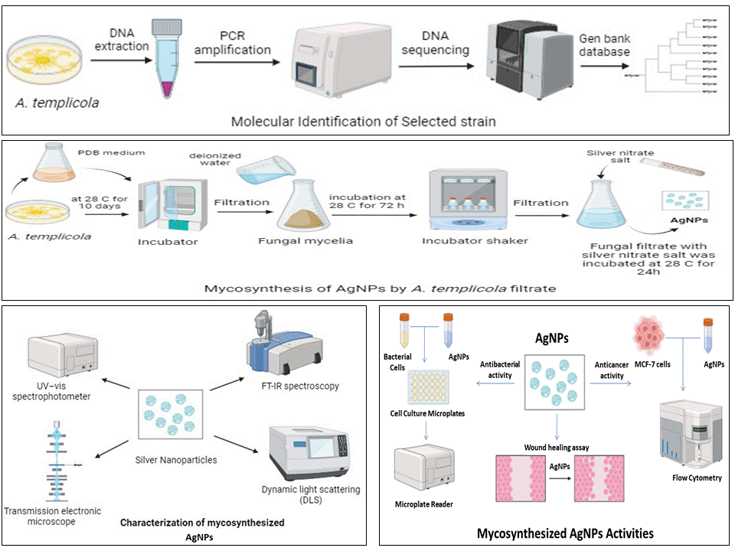
Fig. 1 Experimental design presented in this study to demonstrate molecular identification of selected strain, mycothensysis of AgNPs by Aspergillus templicola OR480102, their characters and activities.
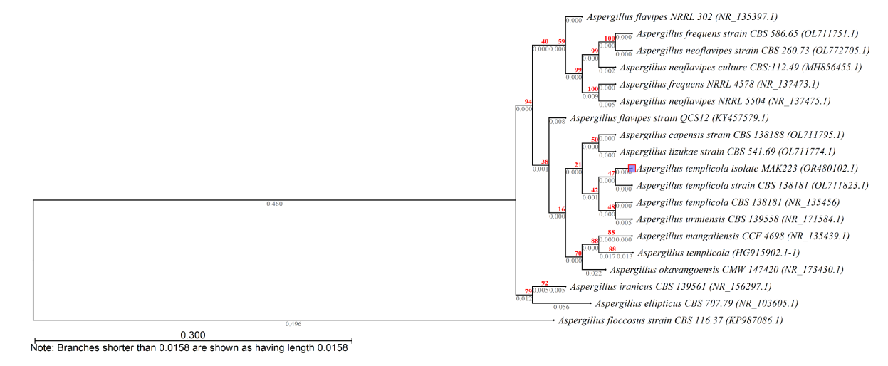
Fig. 2 Evolutionary relationships of Aspergillus templicola (OR480102) with the other related Aspergillus strains in GenBank database.

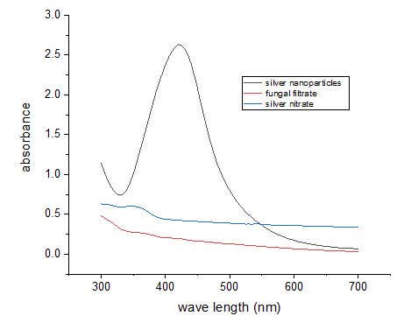
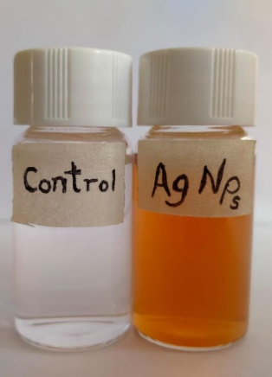

Fig. 3 UV–visible absorption spectrum of AgNPs biosynthesized by Aspergillus templicola MAK 223.
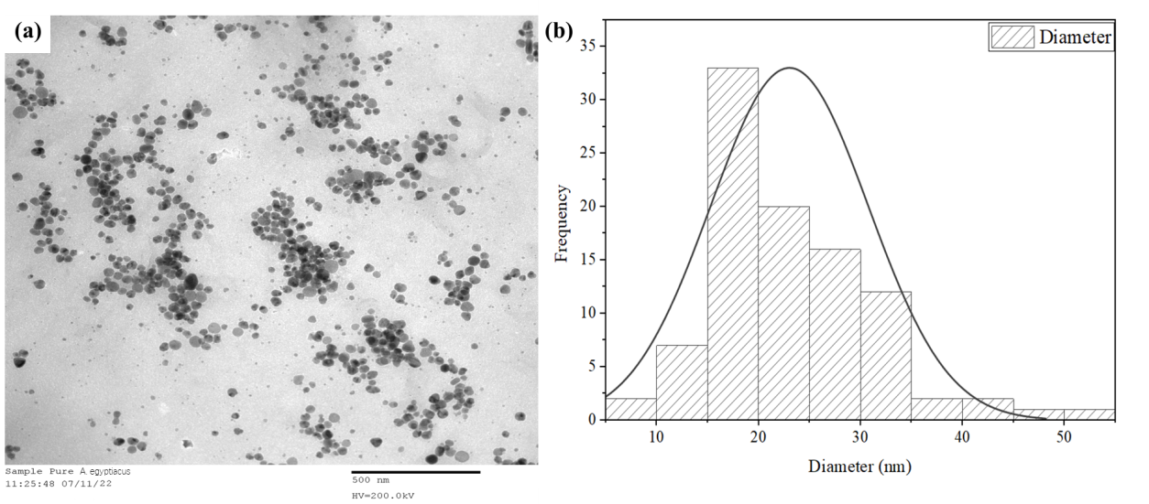
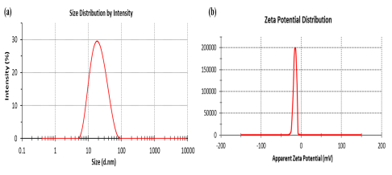
Fig. 4 TEM image of spherical shaped AgNPs between 5-25 nm size with average size of 17.78537 ± 1.36496 nm (scale bar = 500 nm).

Fig. 5 Size distribution of AgNPs solution synthesized by filtrate of Aspergillus templicola MAK 223 (10% gm/mL). (a) dynamic light scattering analysis. (b) zeta potential analysis.

Fig. 6 FT-IR analysis of AgNPs biosynthesized using Aspergillus templicola MAK 223 filtrate.
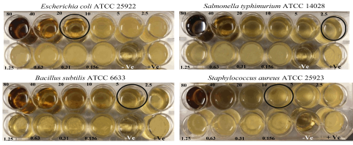
Fig.7 Minimal inhibitory concentration (MIC) of AgNPs against four bacterial strains.

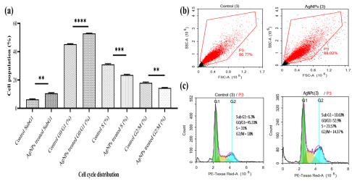
Fig. 8 Flow cytometry analysis of control ‘MCF-7’ cell line and AgNPs-treated cells at 48 h. (a) Bar chart of cell cycle distribution and percent of DNA content in each phase, the results are presented as mean ± standard deviation of three replicates in three independent tests; an asterisk * indicates statistically significant difference from untreated control (P < 0.05; where, ** = P value 0.0017, *** = P value 0.0006, and **** = P value <0.0001); (b) 2D scatter plots (FSC vs. SSC); and (c) DNA histogram displays four phases of cell cycle distribution.

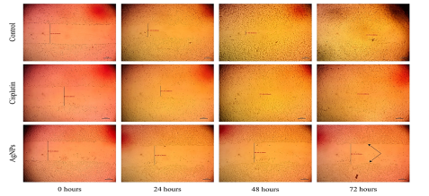

Fig. 9 Images of wound width (mm) at four-time intervals for control, cisplatin, and AgNPs. Black arrows show unhealing of ‘MCF-7’ cells after 72 hours using AgNPs.
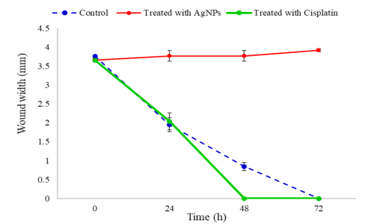
Fig. 10 Wound healing rate. The dashed line represents wound healing rate in control cells. The red and green lines represent the wound healing rate in cells treated with AgNPs and cisplatin, respectively.

Table 1. AgNPs producing Aspergillus spp and their characters, applications.
Aspergillus spp | Characters | Applications | References
A. templicola MAK 223 | Spherical shape with size 17.78 nm | Antibacterial agent, Anticancer agent | Current study
A. fumigatus BTCB10 (KY486782) | Cube-shape with size 0.681 nm | Antibacterial agent, Antiproliferative agents | [39]
A. fumigatus DSM819 | spherical shape with size less than 84.4 nm | Antimicrobial agent, Antitumor agent | [40]
A. Niger | Spherical shape with an average size of 10-100 nm | Antifungal agent | [41]
Aspergillus sydowii | spherical shape with an average size of 1- 24 nm | Antifungal agent, Antiproliferative agent | [6]
A. aureoles | spherical shape with an average size of 12-15 nm | Antimicrobial agent | [42]
A. terreus | Spherical shape with size 14 nm | Antimicrobial agent, Antitumor agent | [43]
A. caespitosus | spherical, hexagonal, and anisotropic crystalline nanoparticles with an average size of 22–57 nm | Antimicrobial agent, Anticancer agent | [44]
A. flavus F5 | Spherical shape with size 12.5 nm | Antibacterial agent, Anti-Candida agent, Acaricide, Photocatalytic agent | [45]
A. flavus | regular and  spherical in shape with size 474.2 nm | Antibacterial agent | [46]
A. flavus | Spherical shape with size 41.9 nm | Antibacterial agent | [47]
A. hortai | Spherical shape with size 57 nm | Antibacterial agent | [48]

Table 2. Values of MIC (µg/mL) of AgNPs against four pathogenic bacteria.
Bacteria | MIC (µg/mL)
Bacteria | AgNPs | Gentamicin
Escherichia coli ‘ATCC 29213’ | 20 | 10
Salmonella typhimurium ‘ATCC 14028’ | 2.5 | 20
Bacillus subtilis ‘ATCC 6633’ | 5 | 20
Staphylococcus aureus ‘ATCC 25923’ | 10 | 10

